Safety Instructions and Installation Manual – Dogrider®

1. Safety Instructions
Please read the following instructions carefully before using the Dogrider seat.
Failure to follow these safety rules may result in serious injury.
By installing the seat on a bicycle, you confirm that you have read all warnings and understand the risks associated with transporting an animal by bike.

Basic safety rules
- Only an adult and experienced cyclist may transport the dog.
- Before every ride, check:
  - that the seat is properly secured,
  - that all components are undamaged,
  - that all screws and connections are tightened.
- Be aware that the dog’s movement changes the bike’s center of gravity—always ride with maximum attention.
- Place and remove the dog only in a safe area without distractions.
- Keep the first rides short and on flat, calm terrain.
- Never leave the dog unattended in the seat.
- The bike may fall over on its kickstand due to the dog’s movement—always secure it safely.
- Watch surrounding traffic, pedestrians, and other cyclists.
If you have any questions, contact us at: info@dogrider.eu

2. Bike Compatibility
You don't have to worry that the Dogrider won't adapt to your needs and won't fit your bike.
Thanks to the carrier design, Dogrider is compatible with approximately 95% of standard bicycles (mountain, trekking, and city bikes with a round seat-tube frame diameter of 28–40 mm).

Installation requirements
- At least 9 cm of free space must be available on the seat-tube frame to attach the mounting clamp.
- A sufficient gap must remain between Dogrider and the handlebars for suspension.
This space allows the steel carrier to flex and absorb shocks on rough terrain.
- The mounting clamp includes integrated cable routing channels.
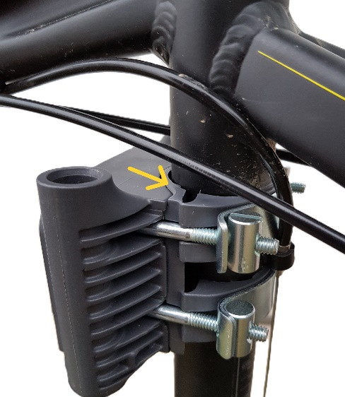
- The spacing of the steel struts ensures maximum stability, even during sharp turns, without touching the frame.

3. Installation Instructions

Step 1 – Assembling the seat
Attach the upper platform (tray) to the seat tub using the supplied screws (bag No. 1).
Choose a position suitable for your dog, then tighten the screws.
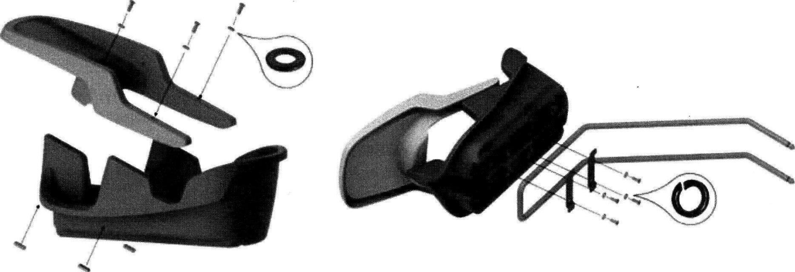

Step 2 – Attaching the mounting clamp to the frame
Using clamps (2x), nuts and bolts, secure the clamping module as high as possible so that it does not interfere with your pedaling.
Maintain a minimum 4 cm gap between Dogrider and the handlebars.
First position the clamp with the plastic sleeves on the seat-tube frame; the sleeves may overlap on the opposite side.
Cables can be routed through the clamp openings on either side, or guided externally.
Check:
- free cable movement,
- proper function of brakes and gears.
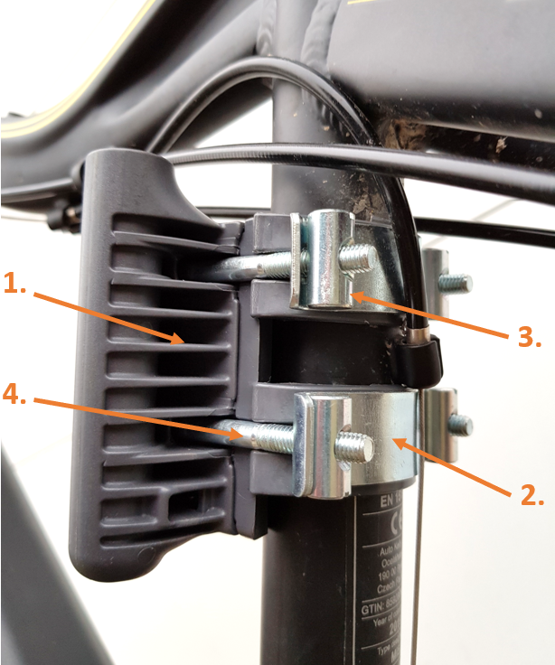

Step 3 – Inserting the steel carrier
Insert the steel carrier into the mounting clamp until it clicks into place.
Verify:
- a minimum 4 cm clearance between Dogrider and the handlebars,
- unrestricted handlebar turning, even under load.

Step 4 – Mounting the seat onto the steel carrier
Remove the steel carrier from the clamp and attach the pre-assembled seat (tub and tray).
Position the seat as far forward as possible so it does not interfere with your pedaling, while avoiding any collision with the handlebars. Dogrider must not restrict steering. Secure using the supplied 4 screws, washers, nuts, and two brackets (bag No. 2).

Step 5 – Removal and locking
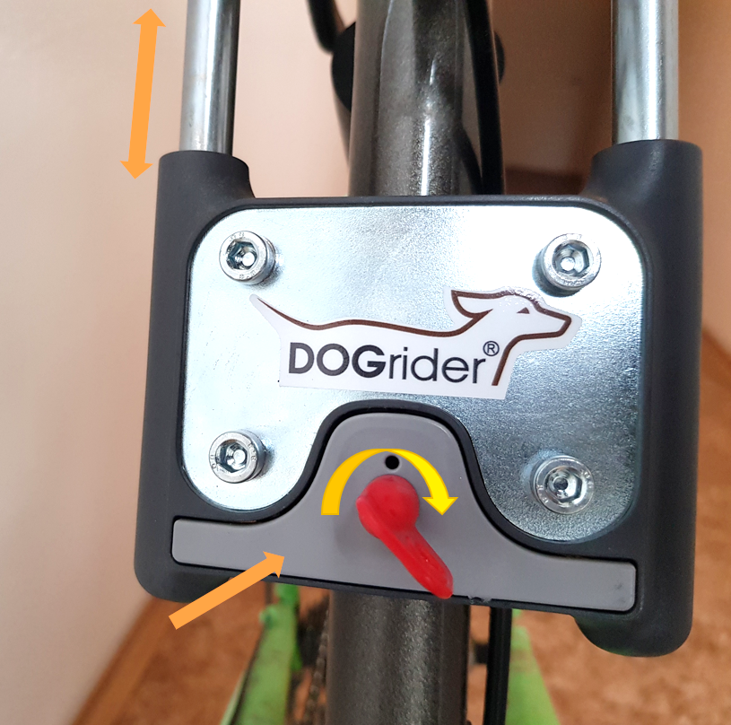
Remove the steel carrier by pressing the button on the mounting clamp.
The seat can be locked using the supplied keys.

4. Safety Harness
The dog must always be secured with the four-point harness.

Procedure
- Connect the four straps to the collar. The collar has two buckles that can be rotated as needed—either symmetrically on the sides (left/right) or along the seat axis (front/back). Choose the most convenient orientation.
- Place the dog in a seated position as far back in the seat as possible.
- Position the collar around the dog’s neck just below the dog’s own collar, which may remain on.
- Tighten the straps so the dog is:
  - securely fixed,
  - yet still comfortable.
Goal: Find the ideal balance—your dog should feel stable and safe, but the straps must not be too tight.

- Advice and Tips

Have you ever come across an atypical frame shape on your bike that seemingly doesn't allow for installation? We've prepared some tried-and-tested tips for you on how to easily help yourself in such cases:

Reversing the mounting clamp
If there is not enough space at the front of the frame, the clamp can be installed in reverse.
Turning the side with holes toward the rear wheel changes the carrier angle, raises the front of the seat, and increases clearance from the handlebars and frame.

Mounting on the seatpost
Suitable for non-round frames.
The seatpost must be inserted at least 4–5 cm into the frame below the clamp attachment point to ensure optimal weight distribution and full system strength, even on rough terrain.

Frame obstacles or protrusions
A hole can be created inside the clamp’s plastic housing for screws or cable guides—maintaining both stability and appearance.

Adjusting the steel carrier angle
The carrier can be slightly bent cold in a vise if needed.
Use protection to avoid damaging the zinc coating (soft jaws, wood, or fabric).
This allows precise ergonomic adjustment while maintaining full corrosion protection.
If you are still unsure whether Dogrider fits your bike or need help with installation, contact us at info@dogrider.eu with a photo of your bike—we will gladly help you find the best solution.

6. Correct and Safe Positioning of the Dog
- The four-point attachment stabilizes the dog at the bike’s center of gravity.
- The smart collar allows quick handling—after some practice, only one buckle needs to be opened.
- The dog may keep wearing its own collar.
- Custom adjustment: After seating the dog, connect all four straps to the collar and tighten them so the dog is secure but relaxed.
The goal is to find the perfect balance: Your furry friend should feel stable and secure, but not be too tightly restrained by the straps. Since every dog ​​is different, we recommend taking a moment during your first ride to individually adjust the length of all straps to your partner's proportions.

- Tip for Maximum Confidence and Safety: Safe Mounting with Dogrider

Are you worried that the seat won't allow you to reach the ground comfortably or that getting on (especially with men's frames) will be more difficult? We have two proven ways for you to enjoy your ride in complete peace of mind.

1. Practice first (before your companion hops in)
If you are not used to mounting with weight at the bike’s center, practice without the dog in a calm area—mounting, stopping, and dismounting. After a few attempts, you will gain confidence, and your dog will feel calmer too.

Telescopic seatpost
If the saddle is still too high for you to safely start off, or you are of a smaller build, we have the ideal solution for you: a telescopic seatpost with handlebar controls.
How does it work in practice?
• When getting on and off: With one push of the lever on the handlebars, you lower the saddle down. You stand safely on the ground with both feet and can bounce off calmly.
• While riding: As soon as you start off, the saddle will rise to your optimal height within a second for healthy and efficient pedaling.
• When getting off: Before stopping, you lower the saddle again, so you stop with your feet flat on the ground.
It is a great accessory that solves ergonomics for every build and increases your comfort, even when you are riding without a saddle.

